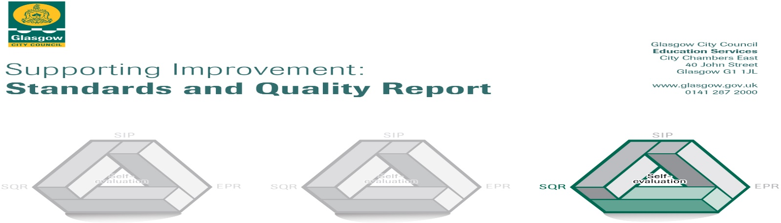

This summary report is provided for parents/carers and partners to outline our achievements this session and our priorities for next session. Throughout this session we have taken forward our priorities as detailed in our School Improvement Plan. Through our processes of self-evaluation, we have identified how we can improve outcomes for our children.
School Context
Miller Primary is a non-denominational primary school for children aged 5-12 in Castlemilk area in the South of Glasgow with most children living within SIMD 1 and 2. The school has the capacity for 240 children, and we currently have 200 children. Our school also has an Enhanced Nurture Provision for children with social, emotional and behavioural needs from across Glasgow. We also have a nurture class within Miller Primary.
Key Developments - We would like to highlight the following improvements and achievements this year:
Leadership of Change: Grade Very Good.
- This year we achieved our Rights Respecting Schools Silver Award.

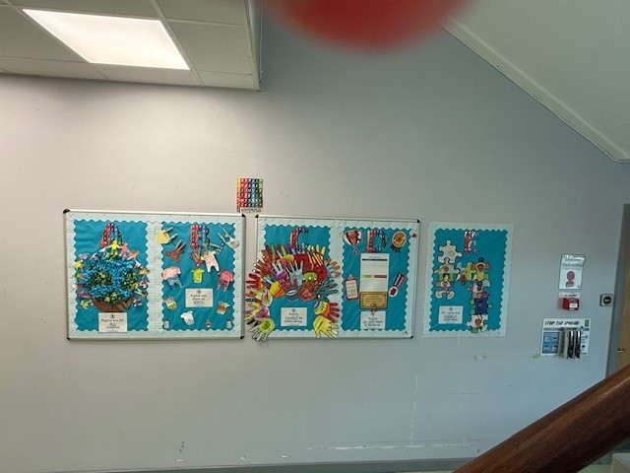

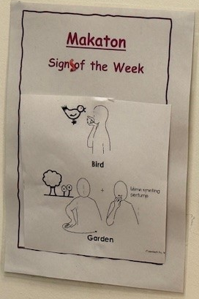
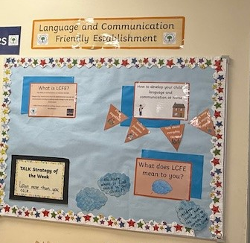
- We are continuing to work on our Language and Communication Friendly Award and all children have been learning Makaton at Assembly.

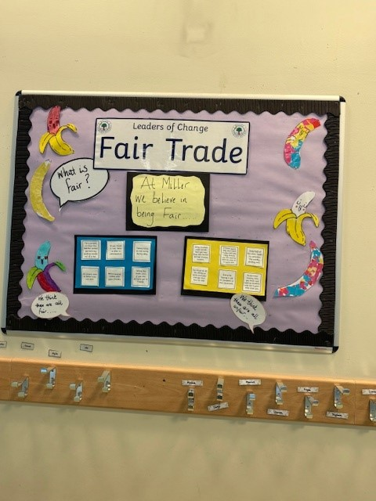
- The children all took part in different leader of change groups, and they took leadership of different parts of school ife. The Eco group were successful in getting the school its 3rd Eco Flag.
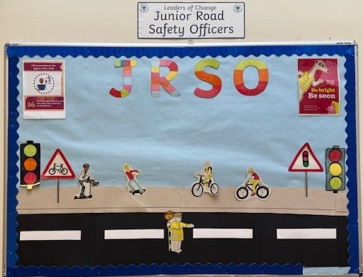
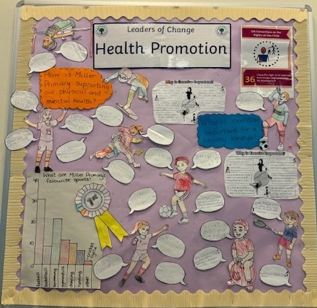
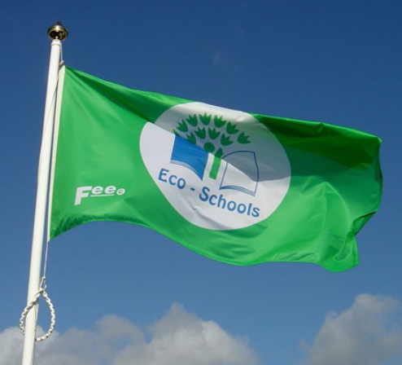
- Almost all children have developed their digital skills throughout the curriculum and our Digital Leaders group worked on developing our next steps in learning.

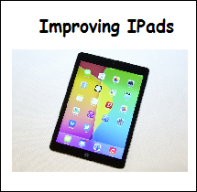
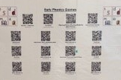
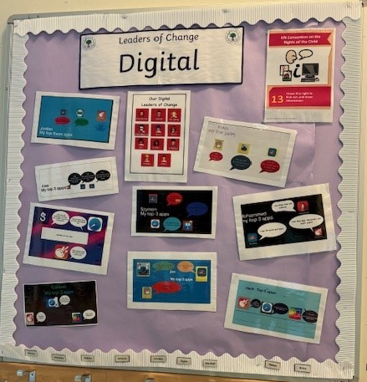

Developments in Learning and Teaching and Assessment. Grade: Very Good.
Progress in Children’s Learning / Raising Attainment and Recognising Achievement. Grade: Good.
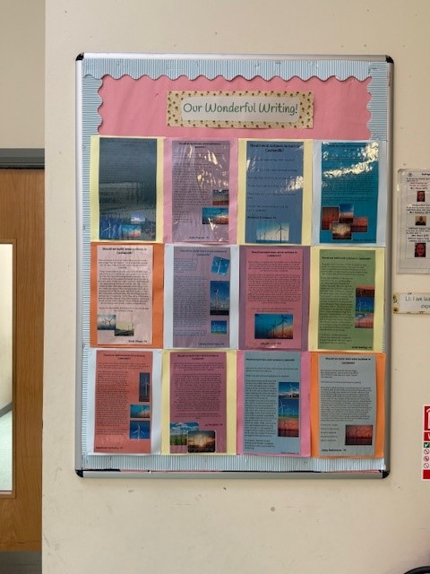
Raising Attainment in Literacy and Numeracy:
- Teaching staff have all taken part in 8 training sessions funded by Pupil Equity Funding about creating a balanced reader and writer and they have used this training to help raise attainment in Reading and Writing. Most children have made progress from their previous levels of attainment.
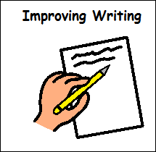
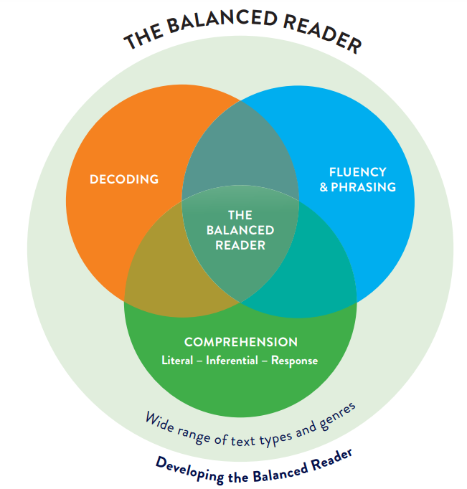

- Our Challenge Leader of Learning continued to focus developing tools for writing for targeted children and most targeted children made progress, however, this was only for two terms due to staffing. Pupil Equity Funding continued to be spent on Support for Learning Workers who work with children successfully on Reading and Numeracy. In Listening and Talking, the children are continuing to develop their skills in being able to talk on task for a purpose and in the upper school they are working on using their skills in persuasion to take part in debates.
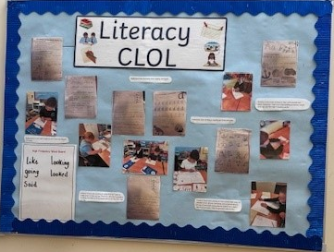

- In Numeracy, most children have learned a variety of strategies to do addition, subtraction, multiplication and division sums. In term 3 and term 4, the children had an intense focus on number, and this has helped a majority of children to make their thinking visible and make progress from their previous learning levels.
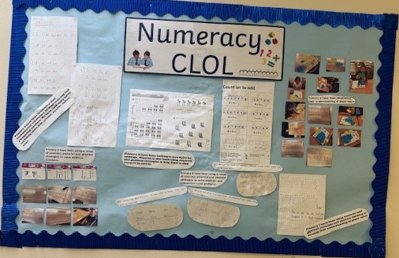

- We made an overall gain across the school in terms of Listening and Talking by 1%. Most children made individual progress, but overall, in Writing, Reading and Numeracy attainment has fallen. In Primary 1, attainment in each area is: 79% Listening and Talking, 67% Reading, 67% Writing and 79% Numeracy. In Primary 4, attainment in each area is: 78% Listening and Talking, 72% Reading, 63% Writing and 66% Numeracy. In Primary 7, attainment in each area is: 75% Listening and Talking, 66% Reading, 59% Writing and 66% Numeracy.
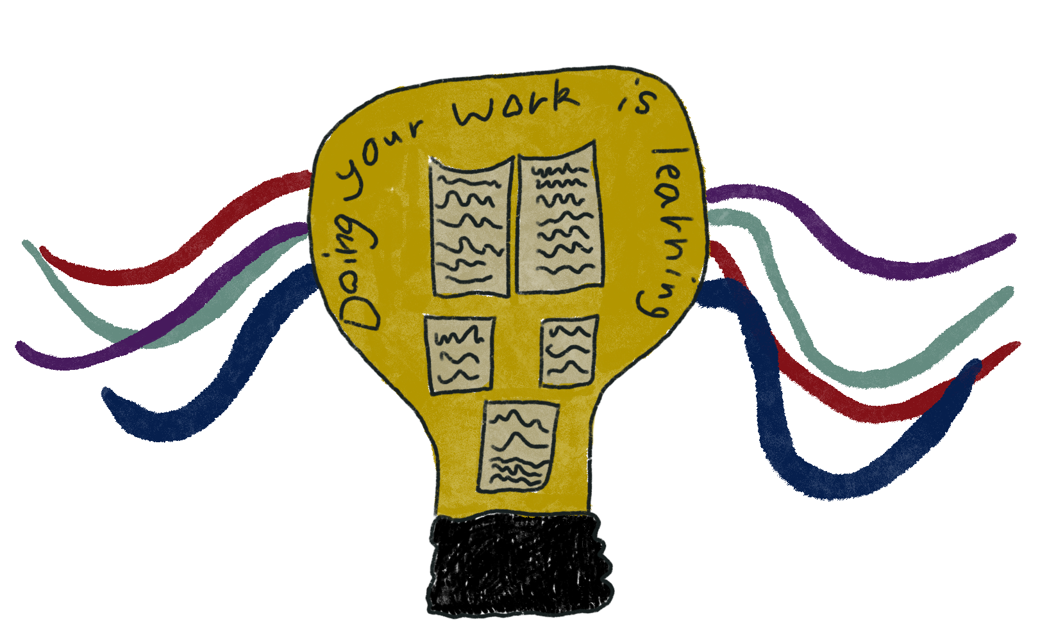

- Primary 5, Primary 6 and Primary 7 participated in the Young Strathclyder programme this session which gave them insight into the different faculties within the University. P7 graduated from the programme at Barony Hall, the University’s place of graduation and they took part in a formal graduation ceremony.


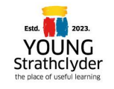

Progress in Promoting Well-Being, Equality and Inclusion: Grade- Very Good
- This session we used our Pupil Equity Funding to continue the Magic Breakfast where every child is offered breakfast and a blether in class as a soft start. We have an 88% uptake in breakfast and staff have reported that the engagement levels of children have risen as a result.

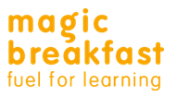

- Headstrong, funded by Pupil Equity Funding, is a wellbeing provider has effectively engaged with key classes within the school to develop children’s mental wellbeing. This has improved most of the targeted children’s abilities to talk about concerns and developed them as confident individuals and effective contributors. Likewise, Impact Arts have effectively engaged with 2 children 1-1 and a group from P7 and a group from P6 to alleviate concerns that the children had, and this has led to strengthened teamworking for all the children involved.
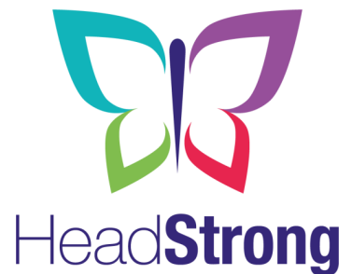


- We have continued to involve all classes in leading their own learning and they have achieved this through organising theme weeks in the school. Most children feel that adults in school listen to their ideas and opinions and use these to make changes. Our school have been working on our Culturally Responsive Pedagogy and Pupil Equity Funding has been spent on representative reading materials and the children will continue to lead this with staff next session.
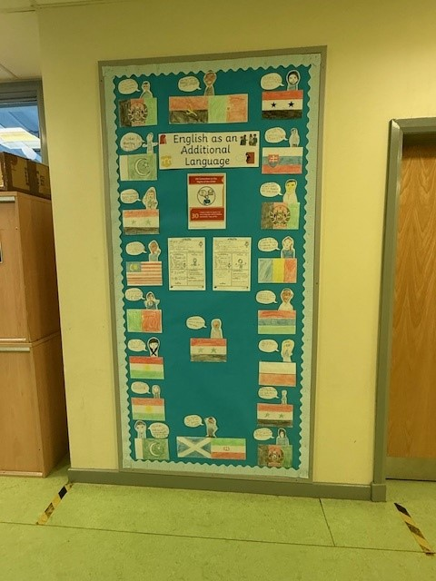
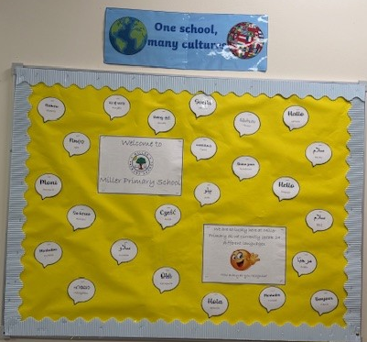

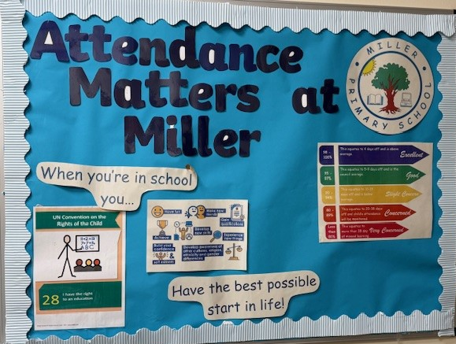
- Attendance interventions by the Principal Teacher have proved very successful in reducing late coming and have successfully improved the attendance of targeted children. Overall, attendance has been maintained across the year. It is essential that we improve our children’s attendance at school as this has an impact on their attainment and achievement.



- Pupil Equity Funding has been spent on supporting the Primary 7 children to experience water sports and they have achieved their Outdoor and Paddle Board Awards. Primary 4 completed their Junior Forrester Award and Primary 6 took part in outdoor learning weekly with Mrs Embleton.


- In the ENP, the children continue to be well supported, and all children have made individual progress with their learning and developing their emotional wellbeing.
Enhanced Nurture

- We continued this session to work developing children’s wider achievement to become Successful Learners, Confident Individuals, Responsible Citizens and Effective Contributors. 36% of children received a gold award, 27% achieved silver, 31% achieved bronze and 4% were awarded pre-bronze.



Here is what we plan to improve next year
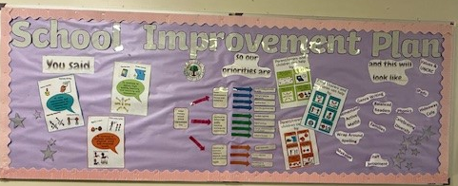

- To raise attainment and achievement in Literacy and Numeracy: To raise attainment in Literacy and Numeracy by using online resources such as Kaligo writing, Sumdog Numeracy and Literacy and Heinemann Active Maths and a back-to-basics approach.
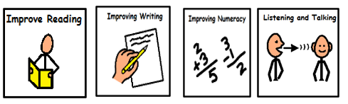

- To continue to deliver high quality learning and teaching and assessment: To use our teacher learning community to explore teaching for effective learning in effective feedback, questioning and differentiation and using these within the classroom to deliver high quality learning, teaching and assessment. We will continue to use digital learning across the curriculum, finish our Language and Communication Friendly Environment.


- To continue to promote children’s physical, social and emotional health: To raise our attendance levels by working with specific families and being robust in our processes to address attendance issues. To promote children’s social and resilience skills by working on emotional literacy, culturally responsive pedagogy and developing consistency in our
relationships policy. Attendance: 88.3%. Exclusion: 2 separate incidents – 4days in total.
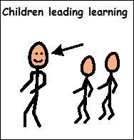

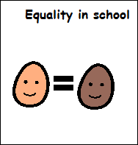

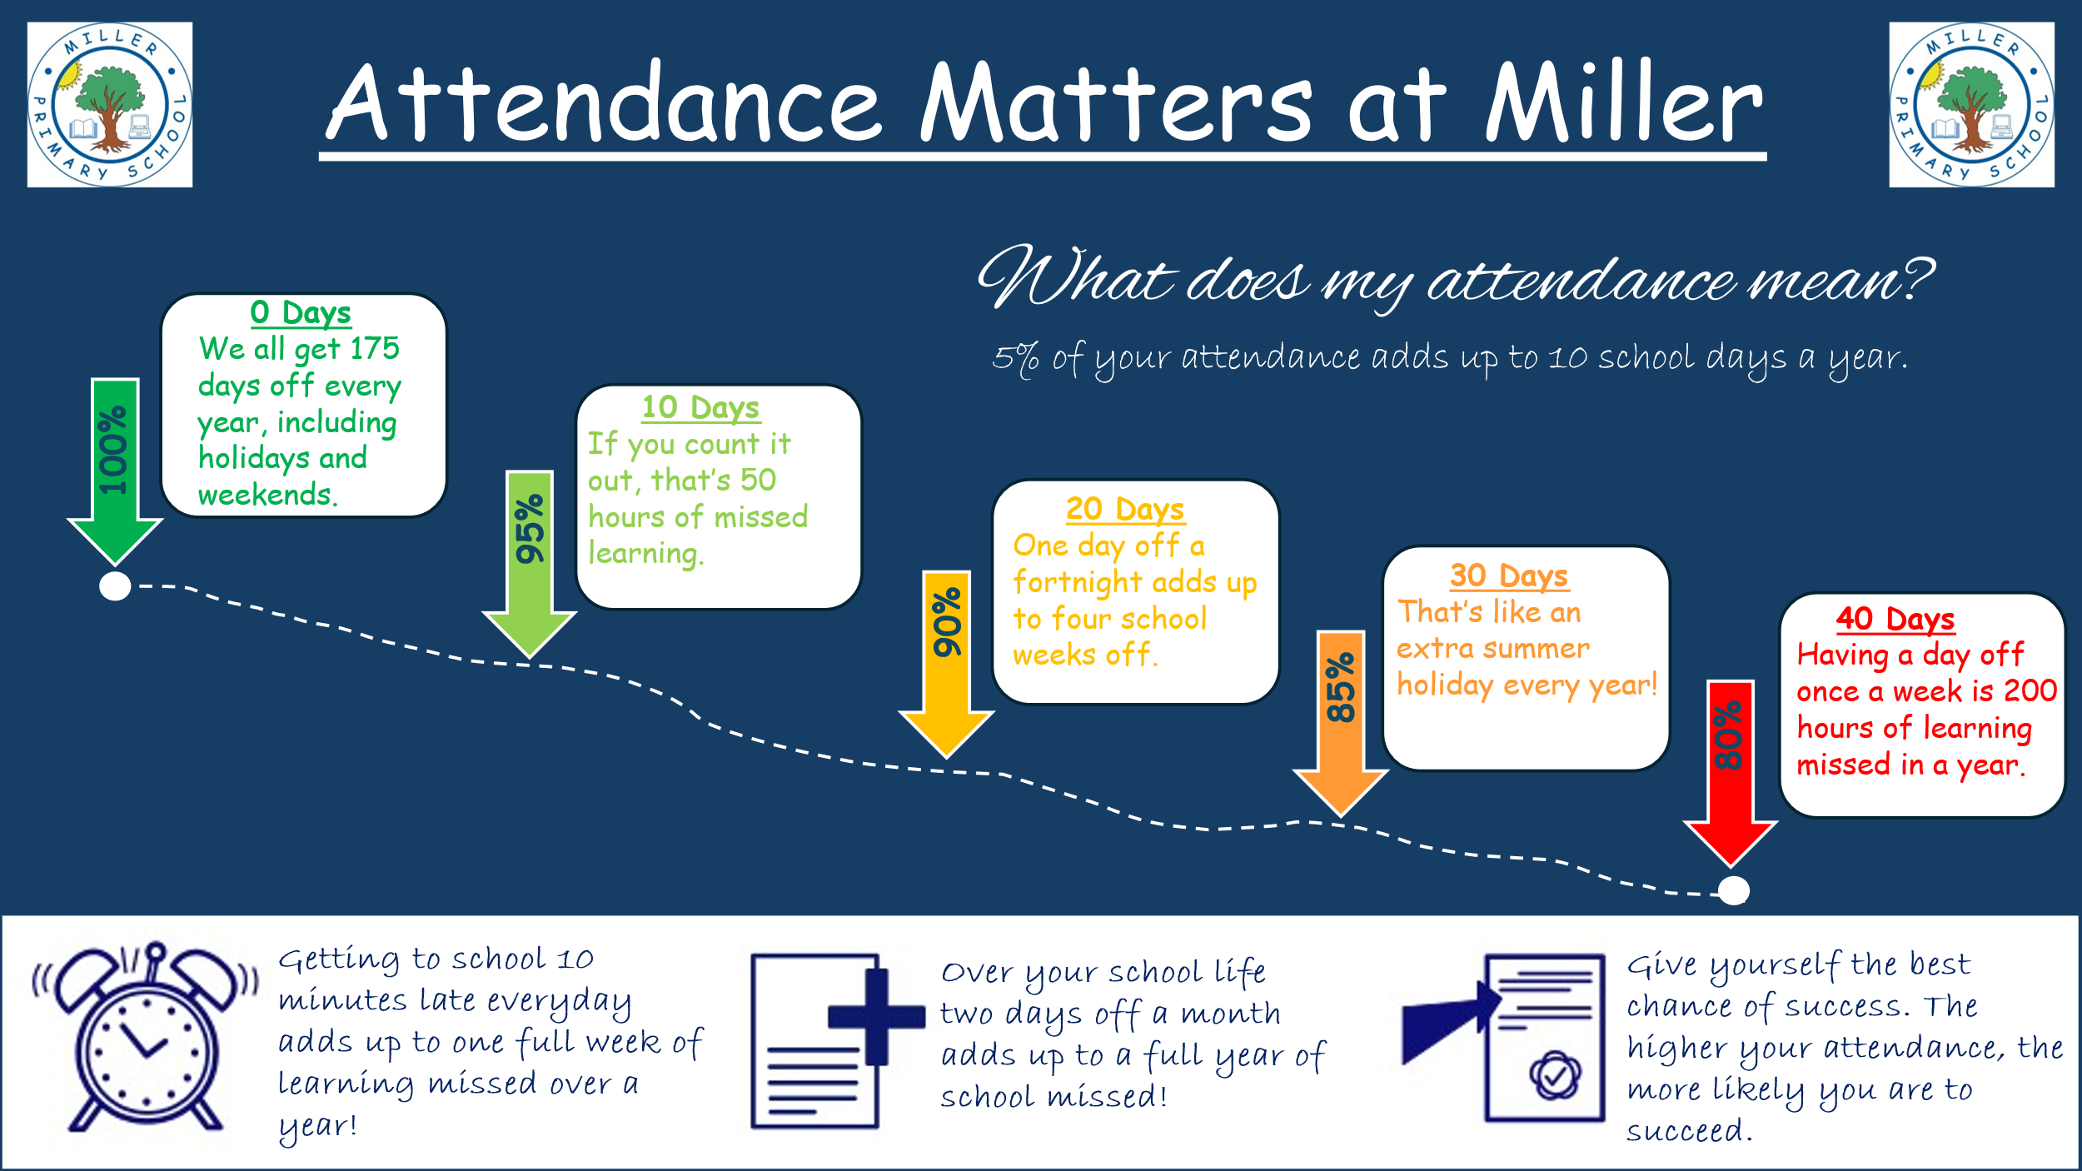

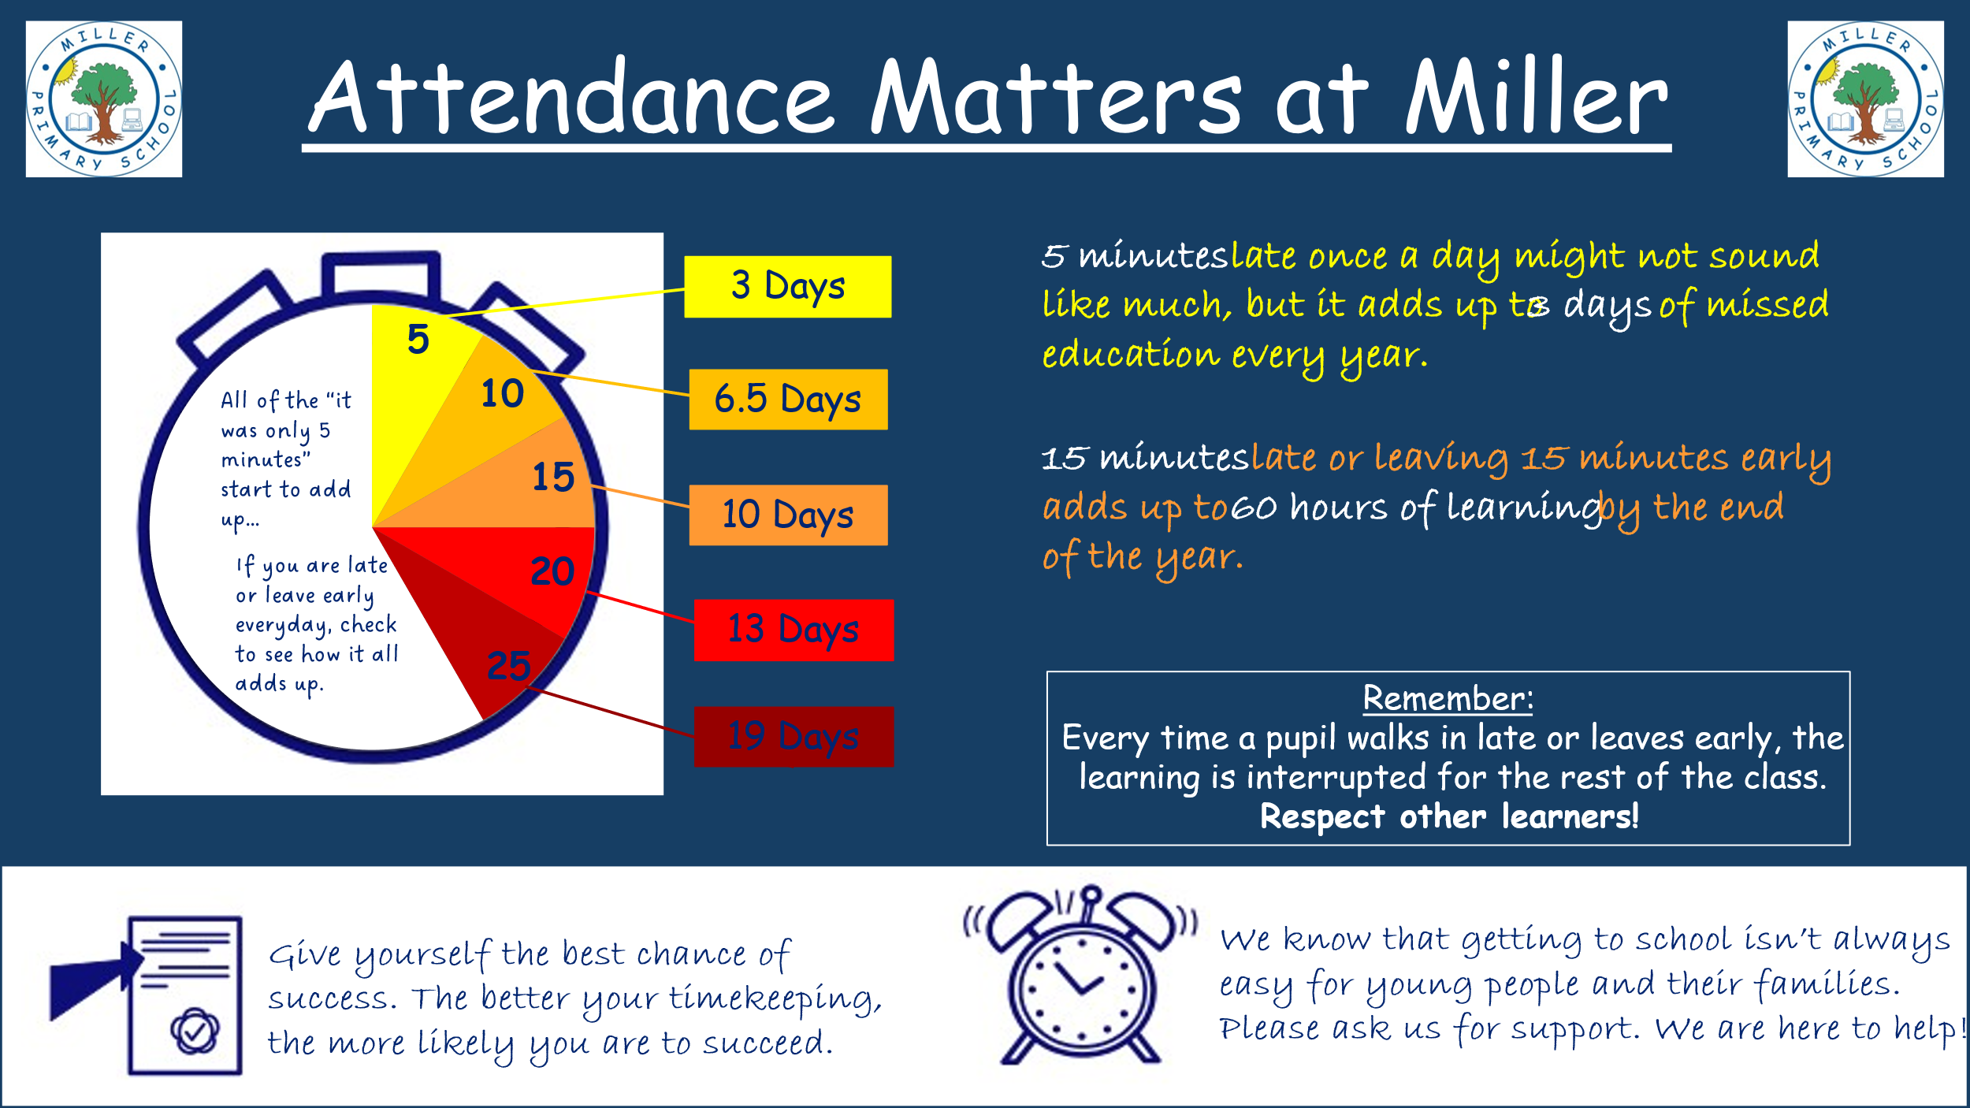

How can you find out more information about our school

E-mail address: Headteacher@miller-pri.glasgow.sch.uk.
Phone: 0141 634 8276.
Address: 20 Ardencraig Road, Glasgow, G45 0EL.

Website: www.miller-pri.glasgow.sch.uk

Find More Information in: Newsletters, Our School Handbook, School Improvement Plan.

